ASSIGNMENT 2: APPLY THE CLUSTERING TECHNIQUES USING UNSUPERVISED LEARNING

1. Aim and Practical Objectives
The primary goal of this assignment is to understand how unsupervised machine learning works by grouping similar data points together without using predefined labels or target answers.
- Apply K-Means, Hierarchical (Ward) and DBSCAN clustering to a real dataset.
- Select the number of clusters using the elbow method and silhouette score.
- Evaluate clusters using Silhouette, Davies-Bouldin index and Adjusted Rand Index (ARI).
- Visualise the clusters in two dimensions using PCA.

2. Theory

2.1 Supervised versus unsupervised learning
In supervised learning, the training data contain input features together with known labels (the correct answers), and the model learns to predict the label. In unsupervised learning there are no labels. The algorithm only receives the input features and must discover hidden structure in the data by itself. Clustering is the most common unsupervised task: it divides the data into groups (clusters) so that points in the same cluster are more similar to each other than to points in other clusters.
Typical applications of clustering include customer segmentation, grouping of similar documents or news articles, image compression and segmentation, anomaly and fraud detection, grouping genes with similar behaviour, and market basket analysis.

2.2 Types of clustering algorithms
Type | Idea | Example
Partitioning | Divides data into k non-overlapping groups around centres | K-Means, K-Medoids
Hierarchical | Builds a tree (dendrogram) of nested clusters | Agglomerative, Divisive
Density-based | Clusters are dense regions separated by sparse regions | DBSCAN, OPTICS
Model-based | Assumes data come from a mixture of distributions | Gaussian Mixture Model

2.3 Distance and similarity measures
Every clustering algorithm needs a way to measure how close two points are. The most common choice is the Euclidean distance; the Manhattan distance and cosine similarity are alternatives.
Euclidean: d(x, y) = √( Σ (xᵢ − yᵢ)² ) Manhattan: d(x, y) = Σ |xᵢ − yᵢ|
Because these distances add up differences of raw feature values, features with a large range dominate the result. Therefore features are standardised (z = (x − μ)/σ) before clustering.

2.4 K-Means clustering
K-Means divides the data into k clusters, each represented by its centroid (the mean of its points). The algorithm works as follows:
- Step 1: choose the number of clusters k and initialise k centroids (k-means++ chooses well-spread starting points).
- Step 2: assign every point to its nearest centroid.
- Step 3: recompute each centroid as the mean of the points assigned to it.
- Step 4: repeat steps 2 and 3 until the assignments no longer change or a maximum number of iterations is reached.
K-Means minimises the within-cluster sum of squares (WCSS, also called inertia):
J = Σₖ Σ_{x ∈ Cₖ} ‖ x − μₖ ‖²
It is fast and simple, but k must be chosen in advance, the result depends on the initial centroids (so several runs, n_init, are used), it prefers round clusters of similar size, and it is sensitive to outliers.

2.5 Hierarchical clustering
Agglomerative hierarchical clustering starts with every point as its own cluster and repeatedly merges the two closest clusters until only one remains. The sequence of merges is drawn as a dendrogram, and cutting the dendrogram at a chosen height gives the clusters. The distance between two clusters depends on the linkage: single (closest pair of points), complete (farthest pair), average (mean of all pairs) or Ward (the merge that increases the total within-cluster variance the least). Ward linkage tends to give compact, equal-sized clusters. The method does not need k in advance, but it is slow for large data sets (at least O(n²) time and memory) and merges can never be undone.

2.6 DBSCAN (density-based clustering)
DBSCAN groups points that are densely packed together and marks points in low-density regions as noise. It has two parameters: eps (the radius of the neighbourhood) and min_samples (the minimum number of points inside that radius). A point is a core point if it has at least min_samples neighbours within eps; a border point lies within eps of a core point but has fewer neighbours itself; every other point is noise. Clusters are formed by linking core points that are within eps of each other. DBSCAN can find clusters of arbitrary shape, does not need k and detects outliers, but it struggles when clusters have very different densities and the result is sensitive to eps.

2.7 Choosing k and evaluating clusters
- Elbow method: plot the inertia against k; the 'elbow' where the curve stops falling steeply suggests a suitable k.
- Silhouette score: for a point i, with a = mean distance to points in its own cluster and b = mean distance to points in the nearest other cluster, s(i) = (b − a) / max(a, b). It ranges from −1 to +1; higher is better, and values near 0 mean overlapping clusters.
- Davies-Bouldin index: the average similarity between each cluster and its most similar cluster; lower is better.
- Adjusted Rand Index (ARI): an external metric that compares the clusters with known labels; 1 means perfect agreement and 0 means random grouping. It can be used here only because the true species labels of the Iris data are available for checking.
Algorithm | Needs k? | Cluster shape | Handles noise | Main weakness
K-Means | Yes | Round, similar size | No | Sensitive to outliers and start
Hierarchical | No (cut tree) | Depends on linkage | No | Slow on large data
DBSCAN | No | Arbitrary | Yes | Sensitive to eps, varying density

2.8 Worked example: K-Means on a small data set
Take six one-dimensional points 1, 2, 3, 10, 11, 12 and k = 2, with initial centroids 2 and 3.
Iteration | Cluster 1 points | Cluster 2 points | New centroids
1 | 1, 2 | 3, 10, 11, 12 | 1.5 and 9.0
2 | 1, 2, 3 | 10, 11, 12 | 2.0 and 11.0
3 | 1, 2, 3 | 10, 11, 12 | 2.0 and 11.0 (no change, stop)

In iteration 1, point 3 coincides with the second centroid, so it joins cluster 2 together with the large values. After the centroids are updated, point 3 is nearer to 1.5 than to 9.0 and moves to cluster 1. In iteration 3 nothing changes, so the algorithm has converged. The final within-cluster sum of squares is (1 − 2)² + (2 − 2)² + (3 − 2)² + (10 − 11)² + (11 − 11)² + (12 − 11)² = 4.

3. Dataset Description
The Iris dataset (Fisher, 1936) from scikit-learn: 150 flowers described by 4 measurements (sepal length, sepal width, petal length, petal width). The three species labels are NOT used for clustering; they are used only afterwards to check how well the clusters match reality. All features were standardised (mean 0, variance 1) before clustering because distance-based algorithms are sensitive to scale.

4. Procedure
Scale the features; run K-Means for k = 2 to 8 and record inertia and silhouette score; apply K-Means (k=3), Hierarchical clustering (Ward linkage, k=3) and DBSCAN (eps = 0.9, min_samples = 5); compare them using internal metrics (Silhouette, Davies-Bouldin) and the external metric ARI; project the result to 2D with PCA.

5. Observations and Results

5.1 Choosing the number of clusters
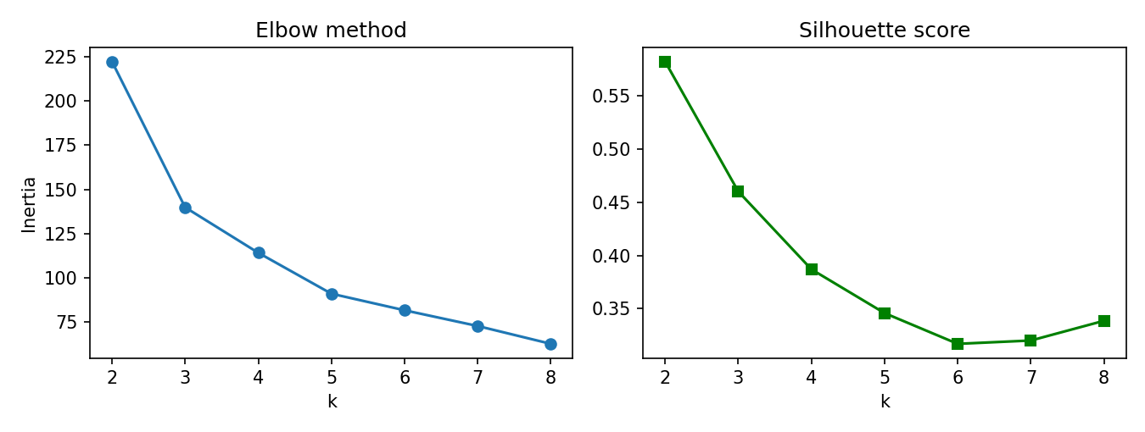
Figure 1: Elbow method (left) and silhouette score (right) for k = 2 to 8
The elbow curve bends at k = 3 (inertia falls from 222.4 at k=2 to 139.8 at k=3, then more slowly). The silhouette score is highest at k = 2 (0.582) because setosa is far from the other two species, which overlap. k = 3 was chosen as it matches the elbow and gives a more informative grouping.

5.2 Comparison of clustering algorithms
Algorithm | Clusters | Noise | Silhouette | Davies_Bouldin | ARI
K-Means (k=3) | 3 | 0 | 0.460 | 0.834 | 0.620
Hierarchical (k=3) | 3 | 0 | 0.447 | 0.803 | 0.615
DBSCAN (eps=0.9) | 2 | 4 | 0.598 | 0.569 | 0.552
Table 1: Internal metrics (Silhouette, Davies-Bouldin) and external metric (ARI) for each algorithm
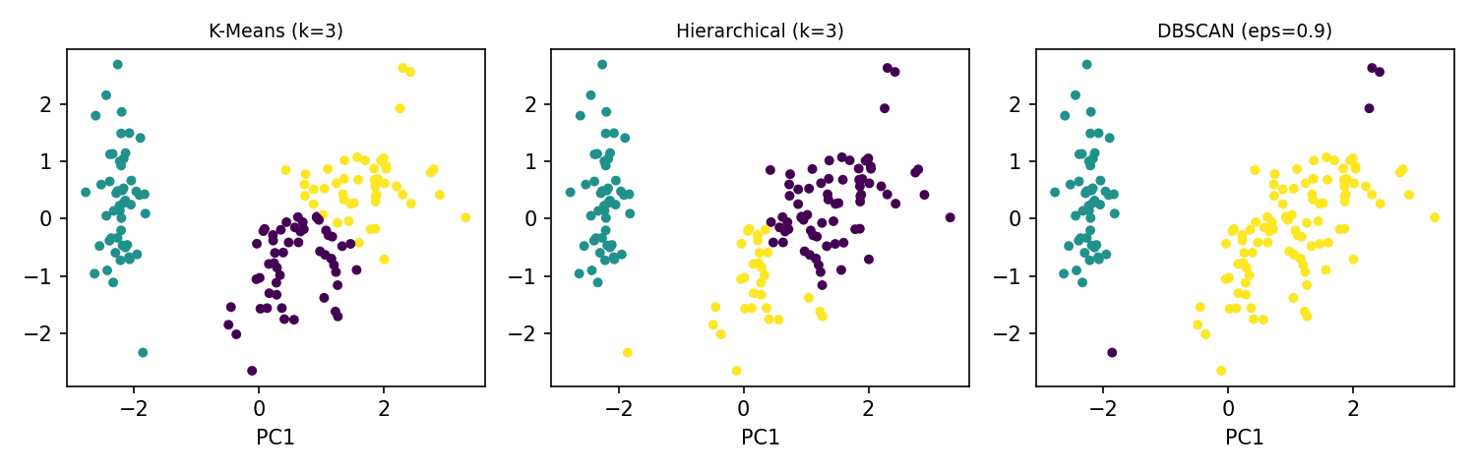
Figure 2: Clusters from each algorithm projected on the first two principal components
- K-Means and Hierarchical clustering give almost the same result (ARI 0.620 and 0.615). Setosa is separated perfectly (all 50 in one cluster).
- Versicolor and virginica overlap: 14 virginica fall into cluster 0 and 11 versicolor into cluster 2.
- DBSCAN finds only 2 clusters and labels 4 points as noise. Its silhouette (0.598) is the highest only because it merges versicolor and virginica, so its ARI (0.552) is the lowest.

5.3 Summary of key findings
Finding | Evidence from the output
Number of clusters (elbow) | k = 3: inertia falls 222.4 → 139.8 → 114.1 for k = 2, 3, 4
Highest silhouette score | k = 2 (0.582); k = 3 gives 0.460
Best agreement with true species | K-Means: ARI = 0.620; Hierarchical: 0.615; DBSCAN: 0.552
Setosa species | Separated perfectly: all 50 setosa flowers are in one K-Means cluster
Noise detected by DBSCAN | 4 points labelled as noise (eps = 0.9, min_samples = 5)
Table: Summary of the main findings of this practical

6. Python Source Code Implementation
The complete Python code used for this practical is given below:

import numpy as np
import pandas as pd
import matplotlib.pyplot as plt
from sklearn.datasets import load_iris
from sklearn.preprocessing import StandardScaler
from sklearn.cluster import KMeans, AgglomerativeClustering, DBSCAN
from sklearn.decomposition import PCA
from sklearn.metrics import silhouette_score, davies_bouldin_score, adjusted_rand_score

# ------------------------------------------------------------------------
# 1. Load and scale the data (class labels are NOT used for clustering)
# ------------------------------------------------------------------------
iris = load_iris(as_frame=True)
X, y_true = iris.data, iris.target
Xs = StandardScaler().fit_transform(X)
print("=== DATASET OVERVIEW ===")
print("Shape:", X.shape, "| Features:", list(X.columns))

# ------------------------------------------------------------------------
# 2. Choosing k for K-Means: Elbow method and Silhouette score
# ------------------------------------------------------------------------
ks = range(2, 9)
inertia, sil = [], []
for k in ks:
km = KMeans(n_clusters=k, n_init=10, random_state=42).fit(Xs)
inertia.append(km.inertia_)
sil.append(silhouette_score(Xs, km.labels_))

print("\n=== ELBOW AND SILHOUETTE ===")
print(pd.DataFrame({"k": ks, "Inertia": np.round(inertia, 2),
"Silhouette": np.round(sil, 3)}).to_string(index=False))

# ------------------------------------------------------------------------
# 3. Apply K-Means, Hierarchical (Ward) and DBSCAN
# ------------------------------------------------------------------------
models = {
"K-Means (k=3)": KMeans(n_clusters=3, n_init=10, random_state=42),
"Hierarchical (k=3)": AgglomerativeClustering(n_clusters=3, linkage="ward"),
"DBSCAN (eps=0.9)": DBSCAN(eps=0.9, min_samples=5),
}
rows, labels = [], {}
for name, m in models.items():
lab = m.fit_predict(Xs)
labels[name] = lab
mask = lab != -1 # ignore DBSCAN noise points
rows.append([name, len(set(lab[mask])), int((~mask).sum()),
silhouette_score(Xs[mask], lab[mask]),
davies_bouldin_score(Xs[mask], lab[mask]),
adjusted_rand_score(y_true, lab)])

result = pd.DataFrame(rows, columns=["Algorithm", "Clusters", "Noise",
"Silhouette", "Davies_Bouldin", "ARI"])
print("\n=== CLUSTERING COMPARISON ===")
print(result.round(3).to_string(index=False))

km_lab = labels["K-Means (k=3)"]
print("\n=== K-MEANS CLUSTER SIZES ===")
print(pd.Series(km_lab).value_counts().sort_index().to_string())
print("\n=== CLUSTER vs ACTUAL SPECIES (cross-tab) ===")
print(pd.crosstab(km_lab, iris.target_names[y_true],
rownames=["cluster"], colnames=["species"]))

# ------------------------------------------------------------------------
# 4. Visualisation using PCA (2 components)
# ------------------------------------------------------------------------
fig, axs = plt.subplots(1, 2, figsize=(9, 3.4))
axs[0].plot(list(ks), inertia, "o-"); axs[0].set_title("Elbow method")
axs[0].set_xlabel("k"); axs[0].set_ylabel("Inertia")
axs[1].plot(list(ks), sil, "s-", color="green"); axs[1].set_title("Silhouette score")
axs[1].set_xlabel("k")
plt.tight_layout(); plt.savefig("fig1.png", dpi=150); plt.close()

Z = PCA(n_components=2).fit_transform(Xs)
fig, axs = plt.subplots(1, 3, figsize=(10, 3.2))
for ax, (name, lab) in zip(axs, labels.items()):
ax.scatter(Z[:, 0], Z[:, 1], c=lab, cmap="viridis", s=14)
ax.set_title(name, fontsize=9); ax.set_xlabel("PC1")
plt.tight_layout(); plt.savefig("fig2.png", dpi=150); plt.close()

7. Execution Output
The output obtained on executing the script (Section 5 is based on it):

=== DATASET OVERVIEW ===
Shape: (150, 4) | Features: ['sepal length (cm)', 'sepal width (cm)', 'petal length (cm)', 'petal width (cm)']

=== ELBOW AND SILHOUETTE ===
k Inertia Silhouette
2 222.36 0.582
3 139.82 0.460
4 114.09 0.387
5 90.93 0.346
6 81.54 0.317
7 72.63 0.320
8 62.54 0.339

=== CLUSTERING COMPARISON ===
Algorithm Clusters Noise Silhouette Davies_Bouldin ARI
K-Means (k=3) 3 0 0.460 0.834 0.620
Hierarchical (k=3) 3 0 0.447 0.803 0.615
DBSCAN (eps=0.9) 2 4 0.598 0.569 0.552

=== K-MEANS CLUSTER SIZES ===
0 53
1 50
2 47

=== CLUSTER vs ACTUAL SPECIES (cross-tab) ===
species setosa versicolor virginica
cluster
0 0 39 14
1 50 0 0
2 0 11 36

8. Interpretation and Conclusion
- Unsupervised clustering recovered the natural structure of the Iris data without using labels: setosa is clearly separated while versicolor and virginica partly overlap.
- K-Means (k = 3) and Hierarchical clustering performed best against the true species (ARI about 0.62); DBSCAN is useful for finding noise but merged two species here.
- A high internal score does not always mean a better grouping, so metrics, plots and domain knowledge should be used together.
- Limitations: the Iris data have only 4 features and 150 samples, and the results depend on the chosen k, eps and scaling.
- Future scope: try Gaussian Mixture Models, use a dendrogram to compare linkages, tune DBSCAN with a k-distance plot, and test on larger real data.

9. Key Terms and Definitions
Term | Meaning
Cluster | A group of data points that are more similar to each other than to points in other groups
Centroid | The mean position of all points in a cluster (used by K-Means)
Inertia (WCSS) | Sum of squared distances of points to their cluster centroid; lower means tighter clusters
Silhouette score | Measure from -1 to +1 of how well a point fits its own cluster compared with the nearest other cluster
Dendrogram | Tree diagram showing the order in which clusters are merged in hierarchical clustering
eps and min_samples | DBSCAN parameters: neighbourhood radius and minimum points needed to form a dense region
Adjusted Rand Index | External measure of agreement between clusters and true labels (1 = perfect, 0 = random)
Reference: Fisher, R. A. (1936). The use of multiple measurements in taxonomic problems. Annals of Eugenics, 7(2), 179-188.

